
TEMASEK JUNIOR COLLEGE
Preliminary Examinations
Higher 2

CANDIDATE
NAME
CIVICS  GROUP |  |  | /

CHEMISTRY 9647/02
Paper 2 Structured Questions 17th September 2010
2 hours
Candidates answer on the Question Paper.
Additional Materials: Data Booklet

READ THESE INSTRUCTIONS FIRST

Write your Civics Group and name on all the work you hand in.
Write in dark blue or black pen on both sides of the paper.
You may use a soft pencil for any diagrams, graphs or rough working.
Do not use staples, paper clips, highlighters, glue or correction fluid.

Answer all questions.
A Data Booklet is provided.

At the end of the examination, fasten all your work securely together.
The number of marks is given in brackets [ ] at the end of each question or part question.

For Examiner’s Use
1
2
3
4
5
6
Total

This paper consists of 19 printed pages and 1 blank page.
1 | Planning (P) |  |  |  |  |  |  |  |  |  |  |  |  |  |  |  |  |  | For Examiner’s Use
 | (a) | The enthalpy change of combustion of ethanol, ΔH_{c} can be determined experimentally under laboratory conditions using the following apparatus.  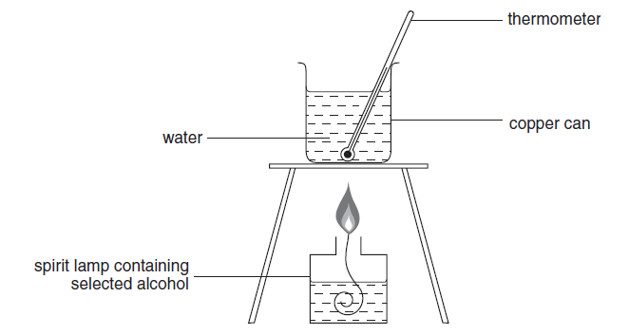
 |  | (i) | Using the apparatus shown above and any other apparatus required that is normally found in a school laboratory, plan a step-by-step method to determine the enthalpy change of combustion of ethanol, ΔH_{c}.
•• Plan
- Fill the copper can with 50.0 cm³ water and set up the apparatus as in the diagram. Measure and record the initial temperature of the water.
- Weigh and record the mass of the entire spirit lamp.
- Light up the spirit lamp. Stir the contents of the copper can until there is a 5 °C rise in temperature. Blow to extinguish the flame and record the temperature in the table
- Reweigh the entire spirit lamp.

Alternative method:
Other than burning ethanol to get a particular temperature rise, you may instead burn a measured mass of ethanol completely OR burn ethanol for a particular length of time.

Show how you would tabulate your results. All necessary measurements should be shown in the table. You may use letters to represent each reading obtained eg T₁, T₂.. to represent temperature readings, M₁, M₂.. to represent mass readings etc.

•
 |  |  |  |  | Mass of spirit lamp + ethanol before combustion / g |  |  |  |  |  |  |  |  | M₁
 |  |  |  |  | Mass of spirit lamp + ethanol after combustion / g |  |  |  |  |  |  |  |  | M₂
 |  |  |  |  | Mass of ethanol burnt / g |  |  |  |  |  |  |  |  | M₁ – M₂
 |  |  |  |  | Initial temperature of water / ºC |  |  |  |  |  |  |  |  | T₁
 |  |  |  |  | Final temperature of water / ºC |  |  |  |  |  |  |  |  | T₂
 |  |  |  |  | Temperature rise of water / ºC |  |  |  |  |  |  |  |  | T₂ – T₁
Using the lettered symbols in your table, show how you would process your results to find the enthalpy change of combustion of ethanol, ΔH_{c}.
[4.2 J of heat energy raise the temperature of 1 cm³ of water by 1 ºC]

••
Heat evolved during combustion = heat gained by water in copper can
= 50.0 x 4.2 x (T₂ – T₁) J

Number of moles of ethanol burnt = (M₁ – M₂) / 46 mol

ΔH_{c} = 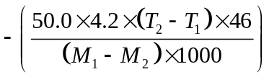kJ mol⁻¹

 |  | (ii) | The apparatus shown in the diagram on page 2 and used in the experiment you have described is inefficient as much of the energy released from the burning ethanol is lost to the atmosphere.  Suggest one simple improvement to the apparatus shown on page 2 that will reduce the loss of heat energy to the atmosphere. The suggested improvement should be supported by an appropriate reason.
••
Any one of the following :
- Provide lagging or insulation on sides but not bottom of can to prevent heat loss through the sides of the can by conduction.
- Put a lid on the copper can to prevent heat loss from the top of can by convection.
- Lower the tripod or raise the spirit lamp to avoid loss of heat by convection.
- Stand the apparatus in a wind shield to exclude draughts.

 |  | (iii) | The equations for the complete combustion of the first five members of the alcohol homologous series are shown below.  Methanol: CH3OH(l) + 1½O2(g) → CO2(g) + 2 H2O(l)  Ethanol: CH3CH2OH(l) + 3O2(g) → 2 CO2(g) + 3 H2O(l)  Propan-1-ol: CH3CH2CH2OH(l) + 4½O2(g) → 3 CO2(g) + 4 H2O(l)  butan-1-ol : CH3CH2CH2CH2OH(l) + 6O2(g) → 4 CO2(g) + 5 H2O(l)  pentan-1-ol: CH3CH2CH2CH2CH2OH(l) + 7½O2(g) → 5 CO2(g) + 6 H2O(l)  There is a trend in ΔHc for these five alcohols. Sketch the trend indicated by the equations.  •
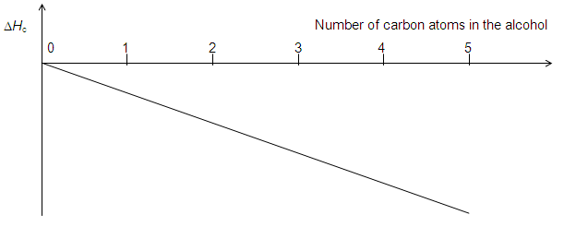
[8]

 | (b) | Labels have come off three bottles each containing an aqueous solution of the following chemicals  aluminium nitrate  lead nitrate  zinc nitrate  You are provided with the reagents NaOH(aq), NH₃(aq), Na₂CO₃(aq), dil H₂SO₄ and dilute HCl.  Using only the above reagents, but not necessarily all of them, you are to plan a method to identify each of the solutions. Maximum credit will be given for the minimum number of tests to positively identify each of the solutions. Marks will be deducted for additional or unnecessary tests.  Record your expected results in the table below.
 |  |  |  |  |  |  | Experiment |  |  | Expected observation with each solution tested and deductions from these observations
 |  |  | 1 |  |  |  | - Add dil HCl or dil H₂SO₄ to separate samples of the three solutions. |  |  | - Pb(NO₃)₂ : White precipitate Al(NO₃)₃: No precipitate  Zn(NO₃)₂: No precipitate  (No change/no reaction is acceptable)
 |  |  | 2 |  |  |  | - Add NH₃(aq) to the two solutions where no precipitate is formed with the first reagent. |  |  | - Zn(NO₃)₂: White precipitate soluble in excess ammonia  Al(NO₃)₃: White precipitate insoluble in excess ammonia
 |  | Or
 |  |  | 1 |  |  |  | - Add NH₃(aq) to separate samples of the three solutions. |  |  | - Zn(NO₃)₂: White precipitate. Soluble in excess ammonia.  Pb(NO₃)₂ : White precipitate. Insoluble in excess ammonia.  Al(NO₃)₃: White precipitate. Insoluble in excess ammonia.
 |  |  | 2 |  |  |  | - Add dil HCl or dil H₂SO₄ to the two solutions where the ppt formed was insoluble in excess NH₃(aq). |  |  | - Pb(NO₃)₂: White precipitate  Al(NO₃)₃: No precipitate  (No change/no reaction is acceptable)
 |  | Or
 |  |  | 1 |  |  |  | - Add Na₂CO₃ to separate samples of the three solutions. |  |  | - Al(NO₃)₃: White precipitate. Effervescence or CO₂ or gas which forms white ppt with lime water.  Zn(NO₃)₂: White precipitate.  Pb(NO₃)₂ : White precipitate.
 |  |  | 2 |  |  |  | - Add NH₃(aq) to the two solutions where no effervescence was seen with the first reagent. |  |  | - Pb(NO₃)₂ : White precipitate. Insoluble in excess ammonia.  Zn(NO₃)₂: White precipitate. Soluble in excess ammonia.
 |  | [4]
 |  | [Total: 12]
2 | (a) | Protein built enzymes form complexes with the metal ions, with the protein acting as a multi-dentate ligand. The enzyme catalase, a haem protein containing an iron complex, acts as a homogenous catalyst to break hydrogen peroxide down into water and oxygen.  2H₂O₂ → 2H₂O + O₂
 |  | (i) | Explain the terms in italics. Describe how it increases the rate of reaction.
- Homogenous catalyst is where the catalyst and the reactants are in the same phase.
- The catalyst provides an alternative reaction pathway with a lower activation energy.
- As the number of reactant molecules having energy ≥ the new lower E_{a} increases significantly, the frequency of effective collisions increases. Hence, the rate of the reaction increases.

 |  | (ii) | Referring to relevant Eº data from the Data Booklet, suggest a mechanism for the catalysis of the decomposition of H₂O₂ by Fe³⁺. [6]
- H₂O₂ + 2Fe³⁺ → O₂ + 2H⁺ + 2Fe²⁺ (Eº_{cell} = + 0.09 V)
- H₂O₂ + 2H⁺ + 2Fe²⁺ → 2H₂O + 2Fe³⁺ (Eº_{cell} = + 1.00 V)
2H₂O₂ → 2H₂O + O₂

- 1m for relevant Eº data

 | (b) | A solution of hydrogen peroxide of original concentration of 5.0 mol dm⁻³ was placed in a bottle contaminated with catalase. The rate of decomposition was measured by withdrawing 10 cm³ portions at various times and titrating with acidified 0.2 mol dm⁻³ KMnO₄. The following results were obtained.  5H₂O₂ + 2MnO₄⁻ + 6H⁺ → 2Mn²⁺ + 8H₂O + 5O₂
 |  |  |  |  |  | Time / min |  |  | Volume of KMnO₄ / cm³
 |  |  |  |  |  | 0  5  10  15  20  25  30 |  |  | 25.0  19.3  15.0  11.5  9.0  7.0  5.5
 |  | (i) |  | Using a graphical method, confirm that the reaction is first order with respect to hydrogen peroxide.
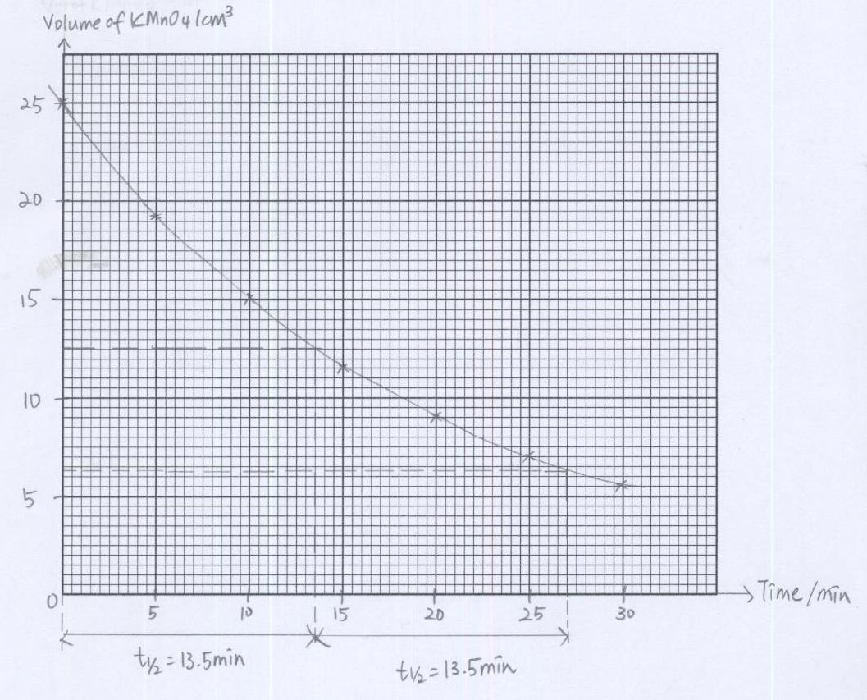

- 1 mark for graph
 |  |  |  | - 1 mark for construction lines to show 2 constant half-lives.
 |  | (ii) |  | Calculate the rate constant and state its units.
Half-life obtained from graph = 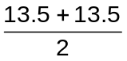 = 13.5 min
- k = 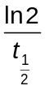 = 0.0513 min⁻¹
- 1 mark for correct units

 |  | (iii) |  | What effect will the presence of the catalase have on the rate constant for the reaction? Explain your answer.
Rate = k[reactants]
- Since all concentration remains constant yet rate increases, thus the value of k must also increase.

 |  | (iv) |  | Calculate the concentration of the hydrogen peroxide at the time the first portion was withdrawn. Hence estimate how long the solution had been in the contaminated bottle. [8]
5H₂O₂ ≡ 2MnO₄⁻

- No of moles of H₂O₂ at time when first portion withdrawn
= 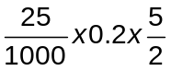 = 0.0125 mol

- Concentration of H₂O₂ = 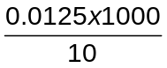 = 1.25 mol dm⁻³

Concentration of H₂O₂ by the time first portion is one quarter of the
original amount (5 → 2.5 → 1.25). Thus 2 half-lives passed.

- Length of time solution has been contaminated = 13.5 x 2 = 27.0 min

 |  | [Total: 14]
3 | (a) | The colours of the silver halides are used in identifying tests for the hydrohalic acids and also for halide salts. Below are some data for the various silver halides.
  Silver halide | Solubility product / mol² dm⁻⁶
  AgCl | 1.6 x 10⁻¹⁰
  AgBr | 7.7 x 10⁻¹³
  AgI | 8.3 x 10⁻¹⁷
 |  | (i) | From the data above, calculate a value for the solubility of AgCl in water.
 |  |  | - Solubility of AgCl = 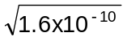= 1.26 x 10⁻⁵ mol dm⁻³
 |  | (ii) | Discuss, with the aid of relevant equations, the solubility of silver chloride in aqueous NH₃. [4]
AgCl Ag⁺ + Cl⁻ ------ (1) K_{sp} = [Ag⁺][Cl⁻]
•
Ag⁺ + 2NH₃ [Ag(NH₃)₂]⁺ ------ (2)

- When NH₃(aq) is added, it react with Ag⁺ to form a complex ion as shown in equilibrium (2), hence lowering the concentration of Ag⁺ in solution.

- By LCP, the position of equilibrium (1) shifts right when the concentration of Ag⁺ decrease, hence the solubility of AgCl increases.
OR

The ionic product of AgCl, [Ag⁺][Cl ⁻], decreases to a value lower than its K_{sp} hence AgCl will dissolve.

 | (b) | The hydrogen halides can be produced from the reactions between the halogens and hydrogen gas.
 |  | By quoting appropriate data from the Data Booklet, explain the trend in the thermal stability of the hydrogen halides. [2]
- Bond energy of H-Cl, H-Br and H-I are 431, 366 and 299 kJ mol⁻¹ respectively.
- As seen from the data, the H-X bond energy decreases down the group resulting in a decrease in the strength of the H-X bond. Hence thermal stability of the hydrogen halides decreases down the group.

 | (c) | One of the halogens, chlorine, can be produced from the electrolysis of a concentrated sodium chloride solution (brine). Brine is passed into a diaphragm cell as illustrated in the diagram below at room temperature.  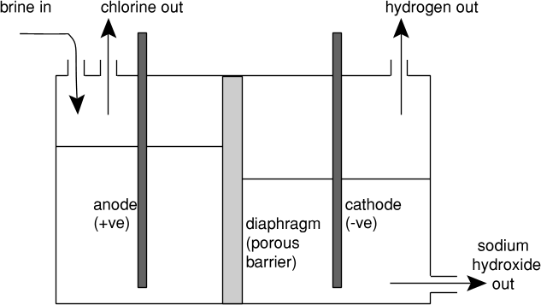  gas out  gas out
 |  | (i) | Write the ion-electron half-equation for each of the electrode reactions.
••
Anode: 2Cl⁻ → Cl₂ + 2e⁻
Cathode: 2H₂O + 2e⁻ → H₂ + 2OH⁻

 |  | (ii) | Explain, with the aid of an equation, what will happen if the diaphragm is not present.
NaOH and Cl₂ would come into contact with each other leading to the formation of sodium hypochlorite solution.
- 2NaOH + Cl₂ → NaOCl + NaCl + H₂O

 |  |  | [Total: 9]
4 | An organic compound A occurs naturally in many food including apple, cheese, apricot, banana, beef, and cauliflower. Compound B is an isomer of compound A.
 | (a) | The following tests are carried out in the order given.  In each case, state all deductions you can make about compound A and/or compound B at that stage.
 |  | (i) | On warming with aqueous alkaline iodine, A gives a yellow precipitate. There is no observable change when B is treated with warm aqueous alkaline iodine.
 |  |  | - A contains either 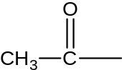 or 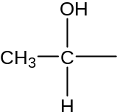but B does not.
 |  | (ii) | Both A and B give a precipitate with 2,4-dinitrophenylhydrazine. [2]
 |  |  | - Both A and B are carbonyl compounds.
 | (b) | When 10 cm³ of gaseous A (M_{r} = 120.0) was completely burnt in an excess of oxygen, only 80 cm³ of carbon dioxide and 40 cm³ of water vapour were formed. All volumes were measured at the same temperature and pressure. Determine the molecular formula of A.  [3]
- No. of C atoms in one molecule of A = 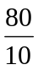 = 8

- No. of H atoms in one molecule of A = 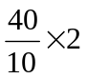 = 8

Let the molecular formula of compound A be C₈H₈O_{x}.
Since the M_{r} of A is 120.0, x = 1.

- Molecular formula of A is C₈H₈O.

 | (c) | Compound B does not react with Fehling’s solution. Using your answers to (a) and (b), suggest the structural formulae of A and B. [2]
 |  |  | 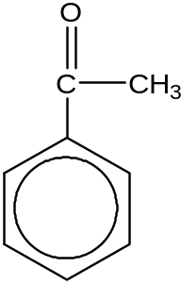  compound A |  |  |  |  | 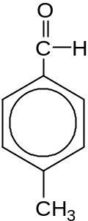  compound B |  |  |  |  | ••  1 mark for each correct structure  Note:  Other positional isomers of B are also accepted.
 | (d) | When A is reacted with a solution of HCN to which a small amount of NaCN has been added, compound C is formed. C consists of a 50:50 mixture of two isomers.
 |  | (i) | Draw the structural formulae of both isomers of C.
 |  |  | 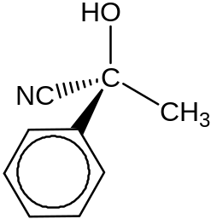  compound C |  |  |  |  | 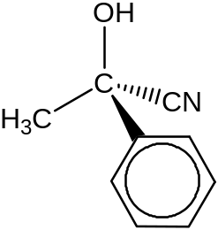  compound C |  |  |  |  | •  1 mark for two correct structures
 |  | (ii) | Suggest why a 50:50 mixture of two isomers is obtained for C. [3]
- There is planar arrangement about the carbonyl carbon.
- The carbonyl carbon can be attacked by CN⁻ either from the top of the plane or the bottom of the plane, each direction of attack with equal probability. This leads to the formation of two mirror images which are non-superimposable (as there is a chiral centre).

 |  |  | [Total: 10]
5 | Zingiberaceae, or the Ginger family, is a family of flowering plants that includes turmeric, ginger and galangal. These three plants are common spices in Thai cuisine.
 | (a) | One of the components in turmeric is curcumin. Curcumin can exist in two tautomeric forms in solution as illustrated by the following equilibrium.  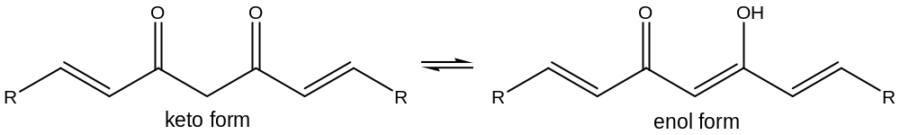  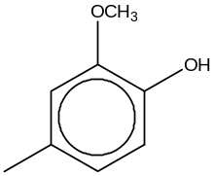  where R represents
 |  | (i) | It was discovered that the percentage of the keto form increases as the temperature increases. Would you expect the enthalpy change of reaction to be exothermic or endothermic? Explain your answer.
- By Le Chatelier’s Principle, when temperature increases, the equilibrium position will shift in a direction to remove the excess heat.
- Since the backward reaction is favoured when the temperature is increased, the backward reaction is endothermic. Hence the forward reaction is exothermic.

 |  | (ii) | The enol form of curcumin is more stable than the keto form. By considering the bonding, suggest a possible reason.
 |  |  | - The enol form is stablised by intramolecular hydrogen bonds between the alcohol and ketone functional groups.
 |  | Curcumin can be used as a pH indicator. In acidic (pH < 7) solutions, it turns yellow whereas in basic (pH > 8.6) solutions, it turns bright red.
 |  | (iii) | Suggest the final colour of the solution containing a few drops of curcumin when 25 cm³ of 1.0 mol dm⁻³ NH₃ was added to 25 cm³ of 1.0 mol dm⁻³ HCl.
 |  |  | - Yellow
 |  | Studies have suggested a wide range of potential therapeutic or preventive effects associated with curcumin. However recent studies have shown that curcumin suppresses the protein hepcidin, potentially causing iron deficiency by forming a complex with iron cations.
 |  | (iv) | Explain why iron cations are able to form complexes.
- Firstly, it is due to the high charge density and hence high polarizing power of the cation which produces a strong tendency towards dative bond (covalent bond) formation with ligands.

- Secondly, it is due to the availability of low lying vacant 3d orbitals in the cation to accommodate the lone pair of electron from the ligands resulting in dative bond formation.

 |  | (v) | Use the Data Booklet to explain the relative stabilities of the Fe(II)/Fe(III) oxidation states in the presence of sodium cyanide. [8]
- Fe³⁺ + e⁻ Fe²⁺ Eº = +0.77 V
[Fe(CN)₆]^{3–} + e⁻ [Fe(CN)₆]^{4–} Eº = +0.36 V
- In the presence of cyanide ions, the electrode potential becomes less positive implying that the Fe(III) oxidation state is less likely to be reduced to the Fe(II) oxidation state hence the +3 oxidation state is more stable.

 | (b) | The characteristic odour and flavour of ginger is caused by a mixture of zingerone, shogaol and gingerol, volatile oils that compose one to three percent of the weight of fresh ginger. Their structures are given below.  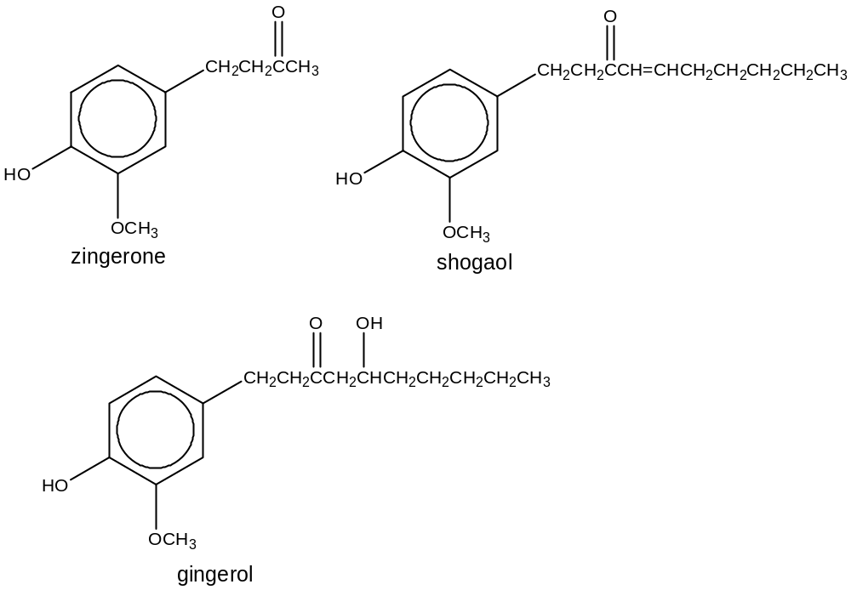
 |  | (i) | Suggest suitable reagents and conditions that can be used to convert shogaol to gingerol in the laboratory.
 |  |  | - Cold, concentrated sulfuric acid followed by heating at 80 °C in the presence of water.
 |  | (ii) | Suggest a chemical test to distinguish gingerol from the other two compounds. Describe clearly what you see.
- PCl₅(s), cold
- White fumes (of HCl) observed

OR

- Acidified potassium dichromate, heat
- Colour of solution changes from orange to green

 |  | (iii) | Suggest suitable reagents and conditions for the following reaction scheme involving zingerone. Draw the structural formulae for the intermediates A and B. [7]  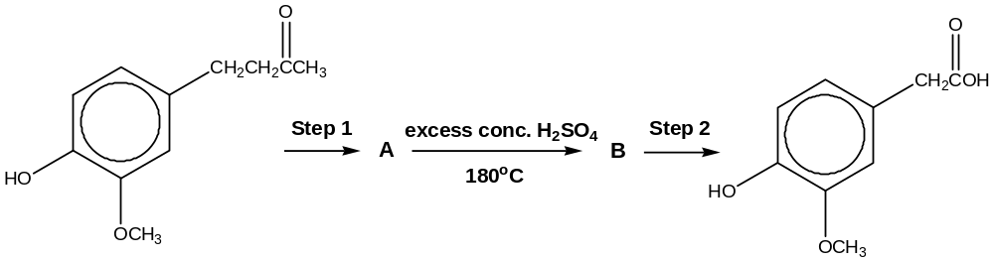  zingerone
••
Step 1: LiAlH₄, dry ether as solvent at room temperature
Step 2: hot, acidic KMnO₄
 |  |  | ••
 |  |  | A  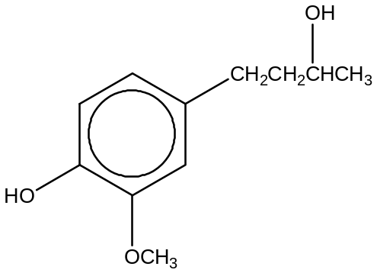 |  |  |  |  |  |  |  | B  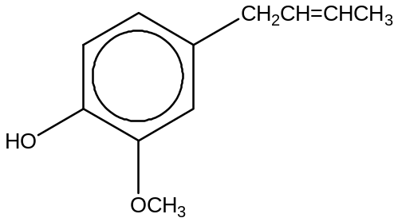
 | (c) | The active component in galangal is given below.  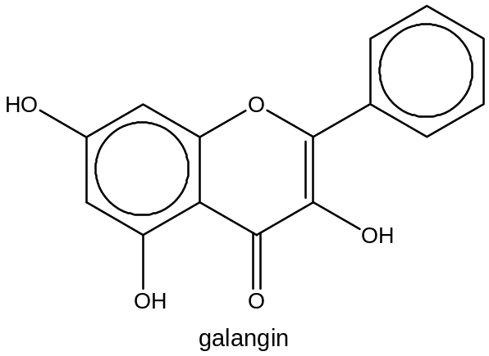  Galangin was reacted with hydrogen gas in the presence of a nickel catalyst at elevated pressure and temperature. State the number of chiral carbons present in the product formed
 |  | - 3
 |  | [Total: 16]
6 | (a) | Trimecaine, one of the first clinical local anesthetics drug administered for surgery has the following structure.  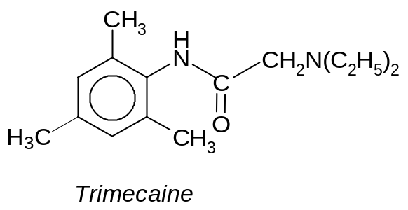
 |  | (i) |  | One molecule of trimecaine contains two nitrogen atoms. Circle the nitrogen atom(s) which you think will cause trimecaine to be basic in nature. Explain your reasoning.
- Circle the nitrogen that is attached to the two ethyl groups.
- Alkyl groups are electron donating, hence lone pair on nitrogen is more available for donation to acid/ dative bonding to a proton, thus rendering it to be basic.
- Electron withdrawing character of the carbonyl group reduces the
electron density on the nitrogen atom, making the lone pair of electrons
less available for dative bonding to a proton.

 |  | (ii) |  | Deduce the structural formula of the organic product formed when trimecaine is treated with HCl at room temperature.
 |  |  |  | - 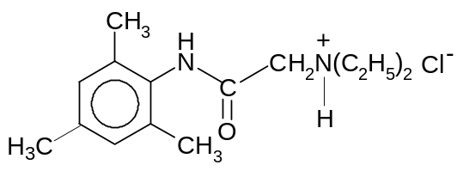
 |  | (iii) |  | Suggest a synthetic pathway (of not more than two steps) for the formation of trimecaine from compound Y. Suggest appropriate reagents and conditions as well as structures of any intermediates formed.  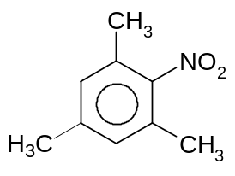  Compound Y
• • •
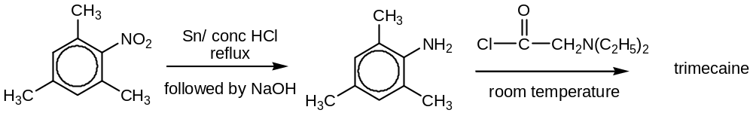 [7]

 | (b) | Amylocaine is another local anesthetic drug administered during surgery. It is used mostly in spinal anesthesia and has the following structure.  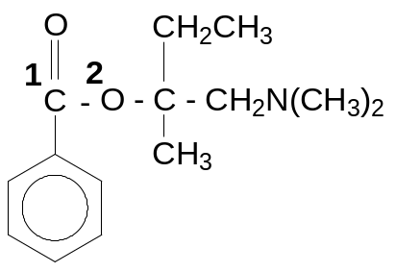
 |  | (i) |  | State the shape of the amylocaine molecule with respect to the carbon that is labelled as ¹C and the oxygen atom that is labelled as ²O respectively.
 |  |  |  | Shape with respect to carbon ¹C |  |  |  |  |  |  |  | Trigonal planar
 |  |  |  | Shape with respect to oxygen ²O |  |  |  |  |  |  |  | V-shape or bent
 |  |  |  | • (1 mark for both correct)
 |  | (ii) |  | State the type of hybridization with respect to carbon ¹C and sketch the shape of the hybrid orbitals around carbon ¹C atom in the amylocaine molecule.
 |  |  |  | Type of hybridization of carbon ¹C atom |  |  |  |  |  |  |  | • sp² hybridised
Shape of hybrid orbitals
•
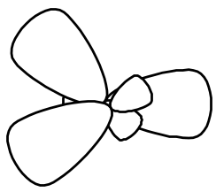 or 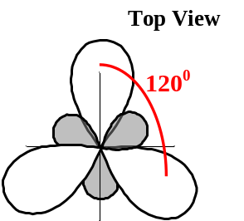

 |  | (iii) |  | Amylocaine undergoes enzymic hydrolysis rapidly in the small intestines when the pH is about 8. Draw the structural formulae of the products obtained from the hydrolysis.  • 1 mark for both correct structures  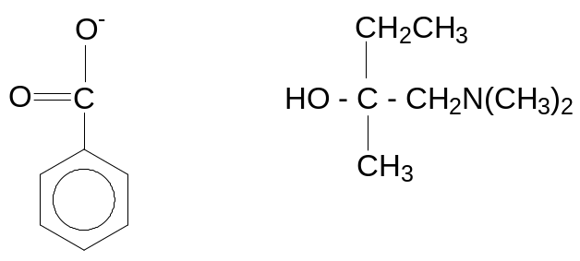 [4]
 |  |  |  | [Total: 11]

